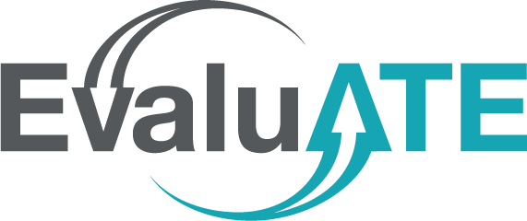
Blank Dissemination Matrix Template
Megan Lopez & Lyssa Wilson Becho | October 2022

Initiative:
 |  | Who are the intended audiences of this project?
 |  | Audience #1: | Audience #2: | Audience #3: | Audience #4:
How will your audiences use the findings or  products of this project? | Intended Use #1:
 | Intended Use #2:
 | Intended Use #3:
This template will support your team in disseminating the important products of initiatives within your project. Dissemination means getting the findings or products of your work to people who can use them, maximizing the benefit of your work without delay.¹ For instructions on using this template, please download the resource Dissemination Matrix Template: How to Share Important Aspects of your Project with Others (bit.ly/dissemination-matrix).

¹ National Institute for Health and Care Research. (2019, January 1). How to disseminate your research. https://bit.ly/3g947dP

